Question 1
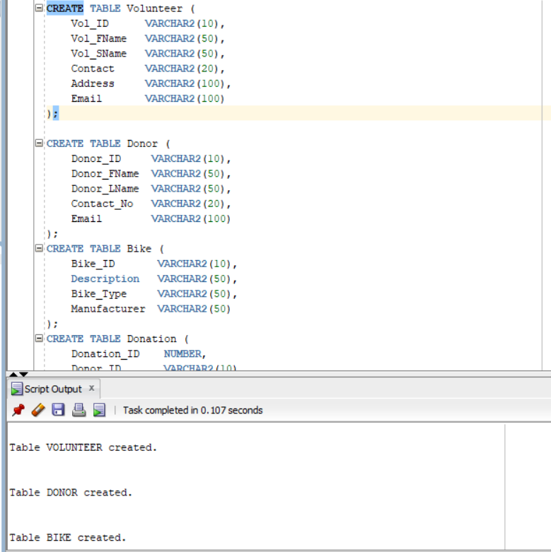

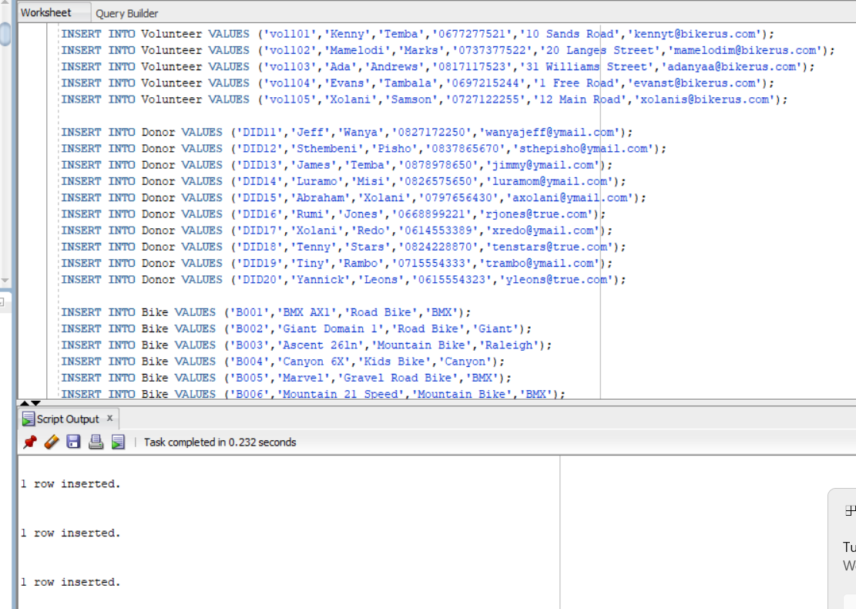
Question 2
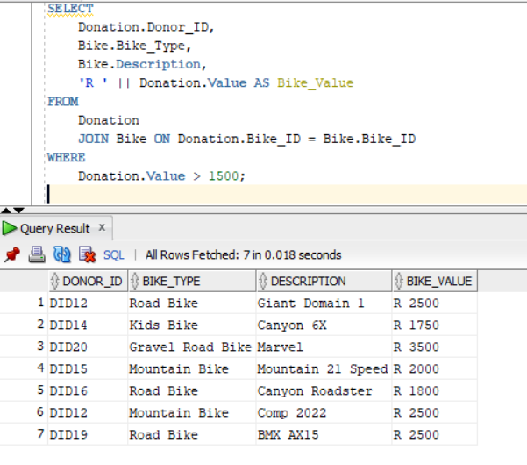

Question 3
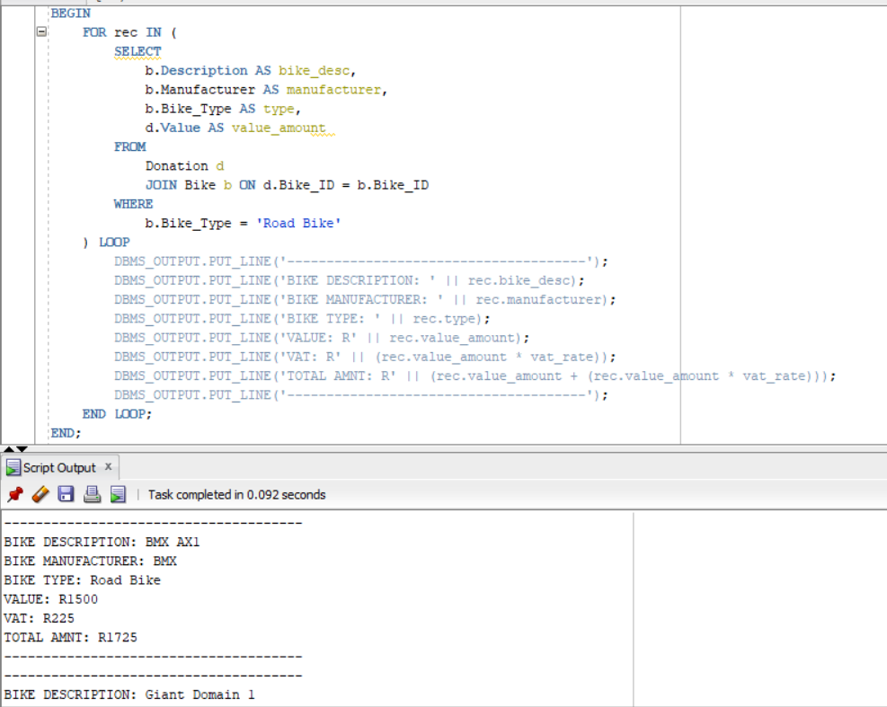

Question 4
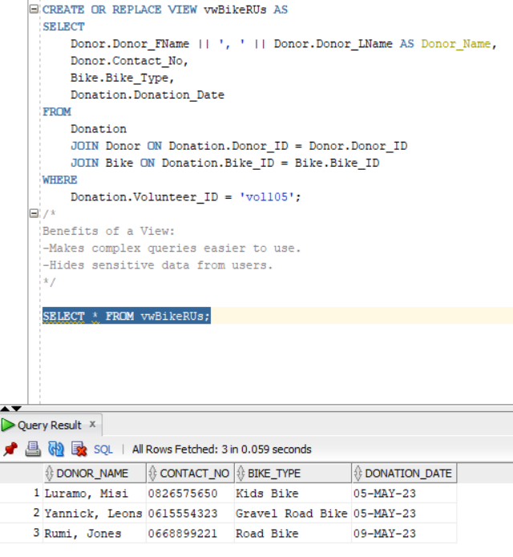
Figure 1-Benefits of SQL Views(DevOps.dev, 2025)Views allow complex queries to be simplified and sensitive data to be hidden from users.

Question 5
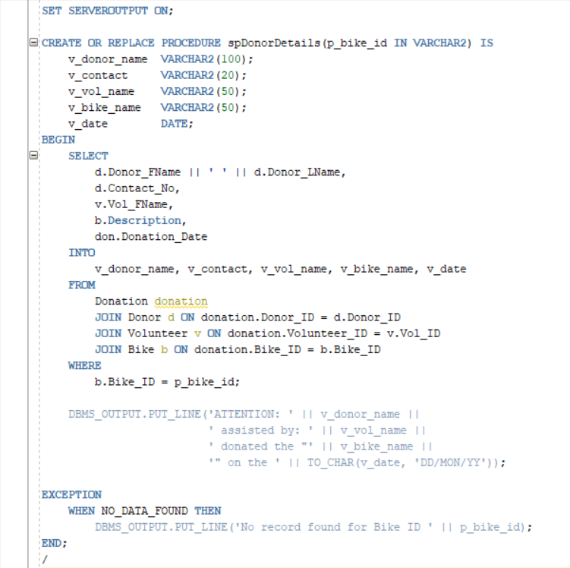
Figure 2- Use of SQL Procedures (W3Schools, 2025) I used a procedure because it helps me group SQL statements together to perform a specific task, making it easier to manage when displaying donor and volunteer information.
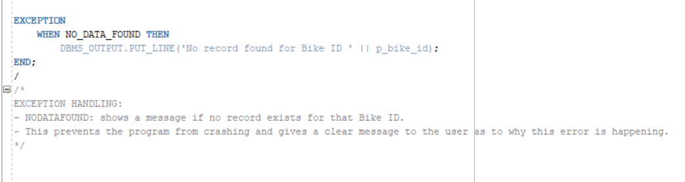

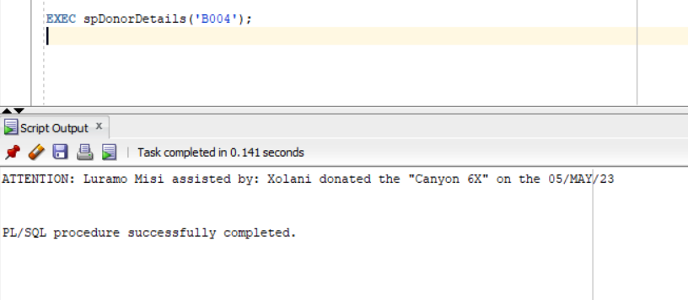
Figure 3-Use of SQL Procedures (W3Schools, 2025) I used this reference to know how to run the task
Question 6
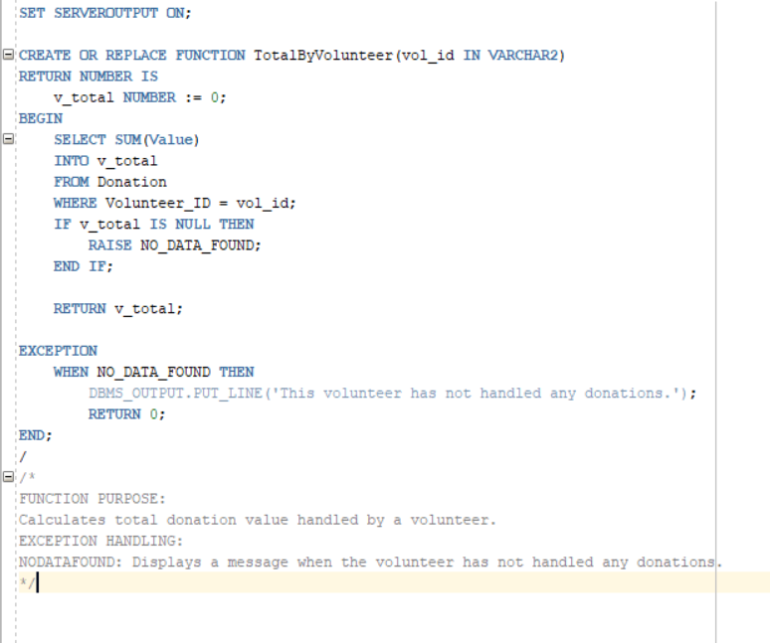
Figure 4-Use of SQL Functions in PL/SQL (GeeksforGeeks, 2024) I used this reference to understand functions so that it can return a single value based on what parameter I have inputted, making calculations like total donations easier.
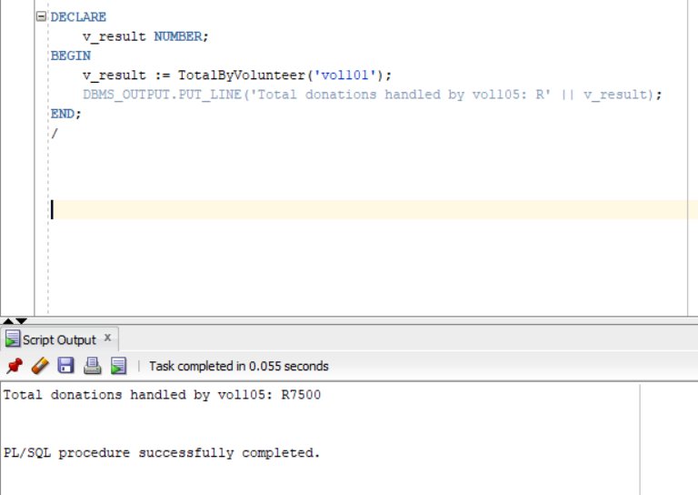
Question 7
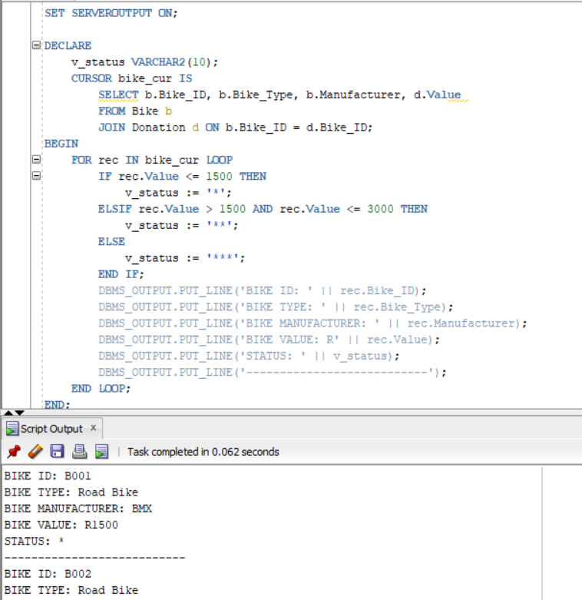
Figure 5-Use of SQL AND Operator (W3Schools, 2025) I used the AND operator in my query to combine multiple conditions when checking bike values, so that only records meeting all criteria for status levels were displayed correctly.

Question 8
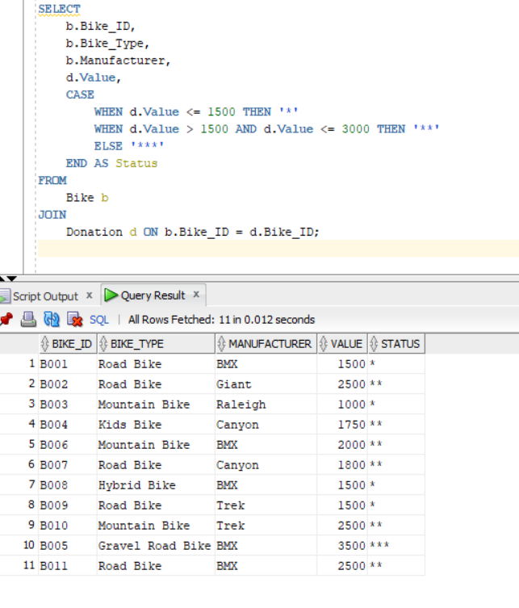
Question 9.1
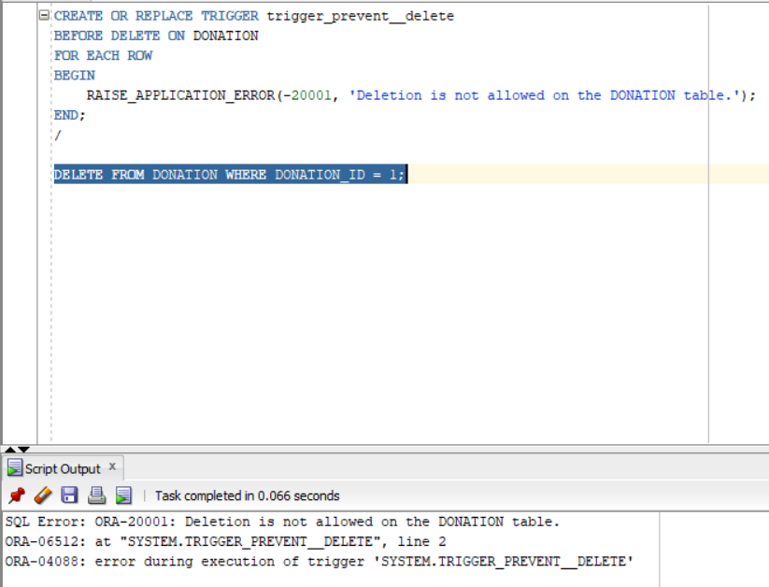
Figure 6-Trigger to prevent deletion from table (Stack Overflow, 2017) I used this reference to show me how to use triggers to block deletions by raising an error before the DELETE operation.
Question 9.2
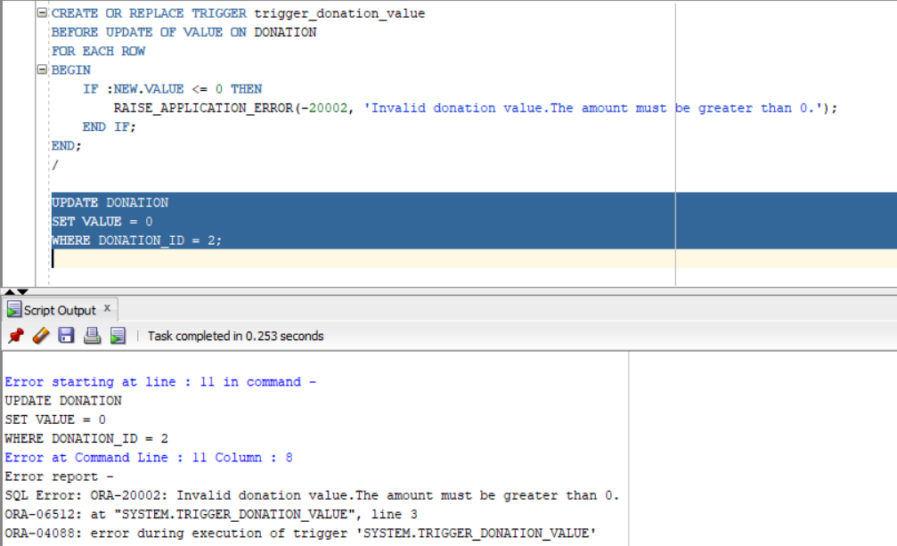

Question 10
How can BikesRUs ensure that sensitive information related to donors, volunteers, bikes, and donations is safe? The first step is to focus on confidentiality. Confidentiality means that only authorized individuals can access sensitive information. One approach is role based access control (Tamanna, 2024). Volunteers, for example, should be limited to inserting or seeing donations, whereas sales staff should be able to view bike inventory and record transactions. Administrators have complete authority to oversee all operations. Encryption is another method of protecting personal data. Donor emails and contact numbers can be encrypted using Oracles Transparent Data Encryption,preventing unauthorized access to the database files. (Tamanna, 2024)

Next, what about integrity? How can BikesRUs keep the data accurate and consistent? One way is to apply constraints (StackOverflow, 2009). Primary and foreign keys ensure that donations always refer to valid donors, volunteers, and bikes, avoiding broken connections and wrong data. Another way is to use triggers to automaticaly enforce rules. (StackOverflow, 2009) For example, a trigger can prevent the deletion of donation records in order to preserve history, or it can ensure that updated donation amounts are always greater than zero. This helps to prevent accidental or unwanted changes Here is an example of a trigger (StackOverflow, 2009):
CREATE OR REPLACE TRIGGER trigger_donation_value
BEFORE UPDATE OF Value ON Donation
FOR EACH ROW
BEGIN
IF :NEW.Value <= 0 THEN
RAISE_APPLICATION_ERROR(-20002, 'Invalid donation value,Must be greater than 0.');
END IF;
END;
/

Finally, how can we ensure that the database is constantly available to volunteers and staff? Availability indicates that the system should remain operational even if something goes wrong (PaperCut, n.d.). Database replication is one way, in which a secondary copy of the database is stored on another server. If the main server fails, the secondary server can take over instantly, allowing volunteers to continue recording gifts or reviewing donor information uninterrupted. (PaperCut, n.d.)Another approach is to use cloudbased high availability, which automaticaly sends traffic to backup servers in the event of hardware failures or network issues. These solutions ensure that the database is always accessible and reliable (PaperCut, n.d.)

Combining all of this results in a secure and reliable environment for BikesRUs. role based access control and encryption secure sensitive donor and volunteer infomation. Constraints and triggers ensure that contribution and bike data are reliable and accurate. Highavailability measures, such as backups, replication, and monitoring, keep the system accessible and prevent interruptions to operations. By using these procedures, BikesRUs may confidently manage donations, support volunteers, and maintain donor trust while lowering the risk of data loss or corruption.

References
geeksForgeeks. 2024. PL/SQL Functions. [online] Available at:< https://www.geeksforgeeks.org/sql/functions-in-plsql/ > (Accessed 8 November 2025)

Himanshu. 2025. SQL Views: Simplifying Data Access and Improving Security. [online] Available at:<https://blog.devops.dev/sql-views-simplifying-data-access-and-improving-security-053b8ce3e526 > (Accessed 8 November 2025)

PaperCut. n.d. The ultimate guide to High Availability methods for Microsoft SQL Server. [online] Available at:< https://www.papercut.com/discover/best-practices/high-availability-methods-for-microsoft-sql-server/ > (Accessed 8 November 2025)

StackOverflow.2009. DB integrity: trigger vs contraints. [online] Available at:<https://stackoverflow.com/questions/1430082/db-integrity-trigger-vs-keys-constraints > (Accessed 8 November 2025)

StackOverflow.2017. Trigger to prevent Any Deleting from Table. [online] Available at:<https://stackoverflow.com/questions/41964979/trigger-to-prevent-any-deleting-from-table > (Accessed 8 November 2025)

Tamanna. 2024. Database Security in SQL(13): What You Need to Know and How to Do It.[online] Available at:< https://medium.com/@tw4512/database-security-in-sql-13-what-you-need-to-know-and-how-to-do-it-9cdfdee2d1d0 > (Accessed 8 November 2025)
W3Schools. (n.d.). SQL AND Operator. [online] Available at:< https://www.w3schools.com/sql/sql_and.asp > (Accessed 8 November 2025)

W3Schools. (n.d.). SQL Stored Procedures for SQL Server. online] Available at:<https://www.w3schools.com/sql/sql_stored_procedures.asp > (Accessed 8 November 2025)

